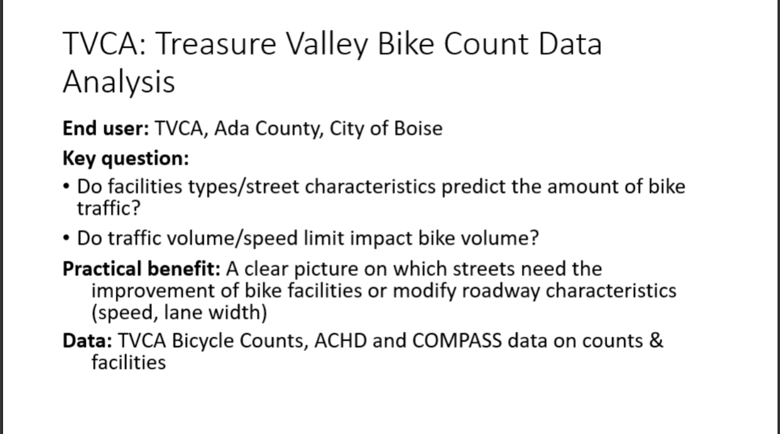

Limitations of Data:

1)Most of the data is incomplete for the intersections.

2)There is no linking identifier.